SIMATS ENGINEERING
(SAVEETHA SCHOOL OF ENGINEERING)
Department of Computer Science and Engineering
CO-2 ASSESSMENT TOOL - 1
Scenario-Based Requirement Analysis
Software Requirement Specification (SRS) Document
Smart Offshore Wind Farm Management Platform
Course: CSA1007 Software Engineering
Submitted by: Manne Praneeth (192372310)
Faculty Name: Dr P Subramanian

1. Introduction
This document presents the Software Requirement Specification (SRS) for the Smart Offshore Wind Farm Management Platform, a web-based and IoT-integrated system designed to monitor, analyze, and manage the day-to-day operations of offshore wind turbines. The purpose of this document is to define the functional and non-functional requirements, system actors, use cases, and constraints associated with the proposed platform, and to serve as the primary reference for its design, development, and validation.
The intended audience for this document includes the project development team, wind farm operations and maintenance staff, and academic evaluators assessing the completeness and correctness of the requirement analysis.

2. Problem Description
Offshore wind farms operate in remote and harsh marine environments where continuous physical monitoring of turbines is difficult, time-consuming, and expensive. Existing management practices rely heavily on fixed inspection schedules and reactive maintenance, which leads to prolonged equipment downtime, delayed failure detection, and inefficient use of maintenance resources.
Weather conditions at sea change rapidly and significantly affect both turbine output and the safety of maintenance operations, yet many existing systems do not integrate real-time weather data into operational planning. In addition, operators often lack a single, unified platform to track turbine health, anticipate failures before they occur, and generate consolidated performance analytics across the entire wind farm.
The proposed Smart Offshore Wind Farm Management Platform addresses these challenges by providing a centralized system for real-time turbine monitoring, predictive maintenance, weather-aware scheduling, and analytics-driven decision-making, thereby improving reliability, safety, and operational efficiency.

3. Scope of the System
The Smart Offshore Wind Farm Management Platform will provide the following capabilities:
- Continuous monitoring of turbine performance parameters such as rotor speed, power output, vibration, and temperature.
- Predictive analytics to detect early signs of equipment failure using historical and real-time sensor data.
- Optimization of energy generation based on turbine condition and weather forecasts.
- Integration of live and forecasted weather data for offshore operations planning.
- Scheduling and tracking of preventive and corrective maintenance activities.
- Generation of operational analytics and reports to support management decision-making.
The system will not directly control turbine hardware; it operates as a monitoring, analytics, and management layer that interfaces with existing SCADA and sensor systems. Physical maintenance execution and low-level turbine control remain outside the scope of this platform.

4. Functional Requirements
FR-1: The system shall collect and display real-time turbine performance data (power output, rotor speed, vibration, temperature) received from SCADA and sensor systems.
FR-2: The system shall analyze historical and real-time sensor data to predict potential equipment failures and generate early-warning alerts.
FR-3: The system shall recommend energy generation optimization strategies based on turbine condition and weather forecasts.
FR-4: The system shall retrieve and display live and forecasted weather conditions, including wind speed, wave height, and visibility, for each turbine location.
FR-5: The system shall allow maintenance engineers to create, assign, and track preventive and corrective maintenance schedules.
FR-6: The system shall generate operational analytics reports covering downtime, energy output trends, and maintenance history.
FR-7: The system shall send automated alerts and notifications to relevant personnel for critical failures or upcoming maintenance activities.
FR-8: The system shall allow administrators to manage user accounts and role-based access permissions.
FR-9: The system shall provide a real-time dashboard displaying the operational status of all turbines in the wind farm.
FR-10: The system shall maintain an audit log of maintenance actions and system-generated alerts.

5. Non-Functional Requirements
Category | Requirement
Performance | The system shall process and display incoming turbine sensor data within 5 seconds of receipt.
Security | The system shall enforce role-based access control and encrypt all data in transit and at rest.
Reliability | The system shall maintain 99.5% uptime and continue to log data during temporary connectivity loss.
Usability | The dashboard shall be usable by operations staff with minimal training, following a consistent and intuitive layout.
Scalability | The system shall support the addition of new turbines and sensor nodes without major architectural changes.
Maintainability | The system shall be modular so that individual components (e.g., prediction engine, weather module) can be updated independently.
Availability | Critical monitoring and alerting features shall remain available even under partial network degradation typical of offshore locations.

6. Actors and Use Cases

6.1 Identified Actors
Primary Actors:
- System Administrator - manages users, roles, and system configuration.
- Operations Manager - monitors overall wind farm performance and reviews analytics.
- Maintenance Engineer - schedules and tracks preventive and corrective maintenance.
- Field Technician - executes maintenance tasks and receives task-related alerts.
Secondary (External) Actors:
- SCADA / Turbine Sensor System - supplies real-time turbine operational data.
- Weather Data Service - supplies live and forecasted weather data.
- Grid Operator - receives energy generation and feed-in data from the platform.

6.2 Use Case Diagram
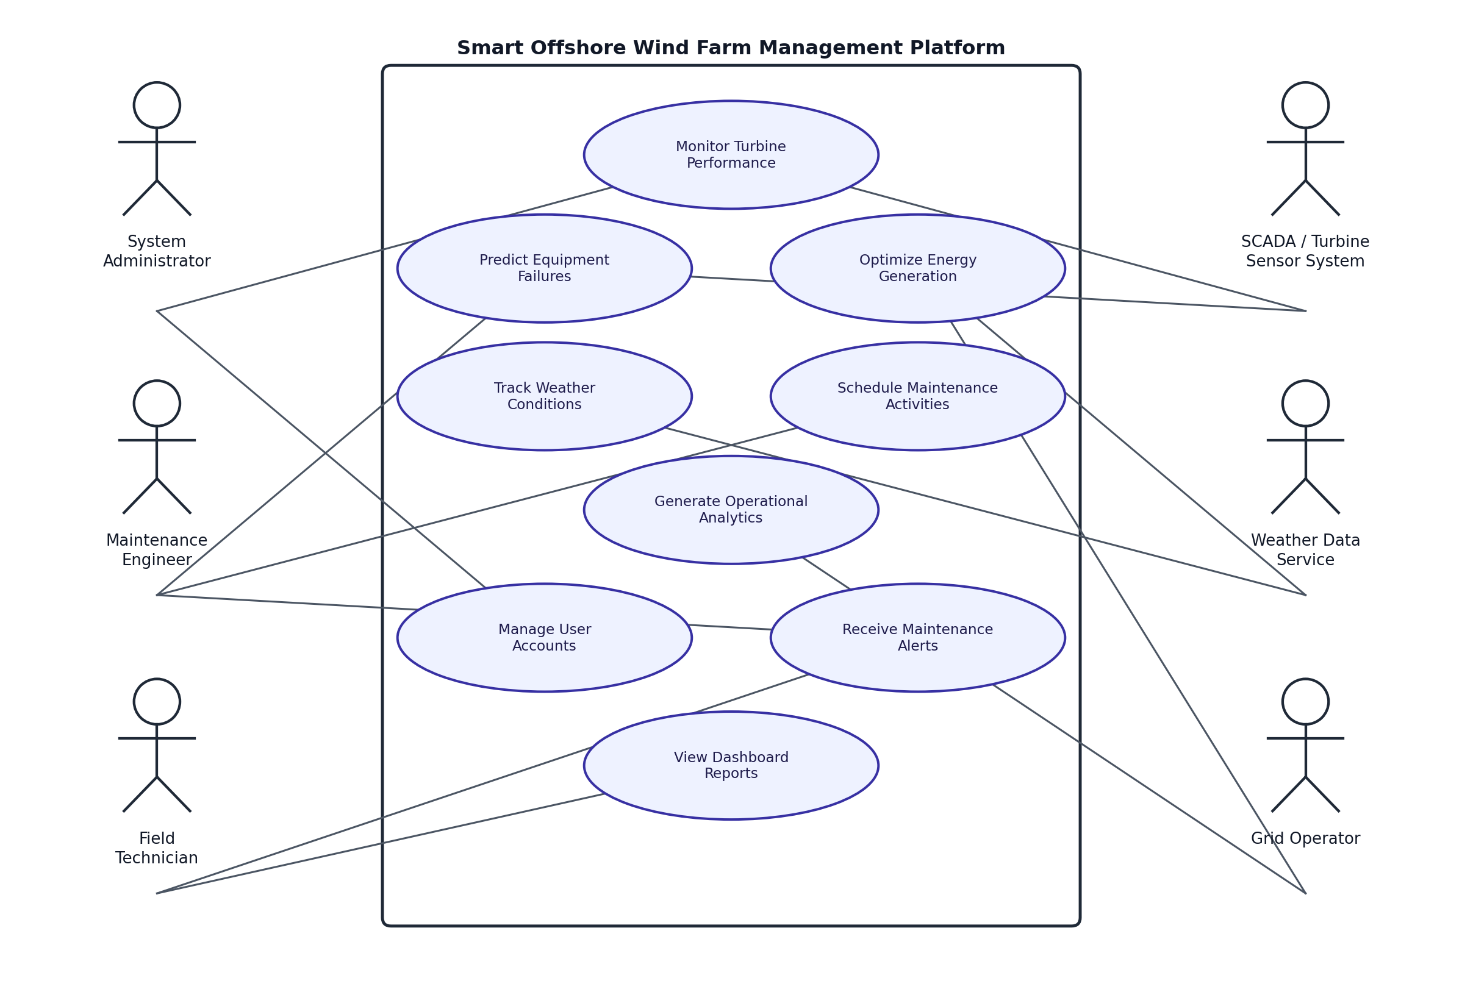
Figure 1: Use Case Diagram - Smart Offshore Wind Farm Management Platform

7. Use Case Descriptions
Use Case | Primary Actor | Description
Monitor Turbine Performance | Operations Manager | View real-time performance metrics (power output, rotor speed, vibration, temperature) for each turbine.
Predict Equipment Failures | Maintenance Engineer | Receive predictive alerts based on analysis of sensor data trends and historical failure patterns.
Optimize Energy Generation | Operations Manager | Review system-recommended adjustments to maximize energy output based on turbine and weather conditions.
Track Weather Conditions | Operations Manager | View live and forecasted weather data relevant to turbine operation and maintenance planning.
Schedule Maintenance Activities | Maintenance Engineer | Create, assign, and monitor preventive and corrective maintenance work orders.
Receive Maintenance Alerts | Field Technician | Receive task assignments and critical alerts related to assigned turbines.
Generate Operational Analytics | Operations Manager | Generate reports summarizing downtime, output trends, and maintenance history.
Manage User Accounts | System Administrator | Create, update, and deactivate user accounts and assign role-based permissions.

8. Data Requirements
- Turbine sensor data - power output, rotor speed, vibration, and temperature, collected continuously.
- Weather data - wind speed, wind direction, wave height, and visibility, retrieved from an external weather data service.
- Maintenance records - work orders, technician assignments, completion status, and maintenance history.
- Historical failure and incident data - used to train and improve predictive maintenance models.
- User and access data - user accounts, roles, and permission levels.
- Energy production and grid feed data - generation output shared with the grid operator.

9. External Interface Requirements

9.1 User Interfaces
A web-based dashboard for administrators and operations staff, and a mobile-friendly interface for field technicians to receive tasks and alerts on site.

9.2 Hardware Interfaces
Integration with SCADA controllers and turbine sensors through industrial communication protocols such as Modbus and OPC-UA.

9.3 Software Interfaces
Integration with an external Weather Data Service API for live and forecasted weather information, and with the Grid Operator's reporting interface for energy feed-in data.

9.4 Communication Interfaces
Offshore data transmission via satellite or 4G/5G links, secured through VPN and encrypted communication channels.

10. System Features
Feature | Description
Real-Time Monitoring Dashboard | Displays live status and key performance indicators for all turbines in the wind farm.
Predictive Maintenance Engine | Analyzes sensor trends to forecast potential failures before they occur.
Energy Optimization Module | Suggests operational adjustments to maximize energy generation.
Weather Integration Module | Combines live and forecasted weather data with operational planning.
Maintenance Scheduler | Manages creation, assignment, and tracking of maintenance work orders.
Reporting and Analytics Module | Generates downtime, output, and maintenance history reports.
Alert and Notification System | Delivers automated alerts for failures and upcoming maintenance.
User and Access Management | Handles account creation and role-based access control.

11. Assumptions and Constraints

11.1 Assumptions
- All turbines are equipped with functioning IoT sensors capable of transmitting data at defined intervals.
- Offshore internet connectivity is available through satellite or 4G/5G links.
- Sufficient historical maintenance and failure data is available to train predictive models.
- The external weather data service provides reliable and timely forecasts.

11.2 Constraints
- Technical: The harsh marine environment may cause sensor or communication failures; limited offshore bandwidth restricts data transmission volume.
- Operational: Physical maintenance visits depend on weather windows and vessel or helicopter availability.
- Economic: Budget limits may restrict the extent of sensor retrofitting on older turbines.
- Legal: The system must comply with maritime safety regulations and data protection requirements.
- Time-related: Predictive alerts must be generated within defined time windows to remain operationally useful.

12. Requirement Validation

12.1 Completeness Check
Each objective identified in the problem statement has been mapped to at least one functional requirement and system feature, confirming that the requirement set addresses the full scope of the assigned scenario.
Objective | Addressed By
Monitor turbine performance | FR-1, FR-9; Real-Time Monitoring Dashboard
Predict equipment failures | FR-2; Predictive Maintenance Engine
Optimize energy generation | FR-3; Energy Optimization Module
Track weather conditions | FR-4; Weather Integration Module
Schedule maintenance activities | FR-5; Maintenance Scheduler
Generate operational analytics | FR-6; Reporting and Analytics Module

12.2 Consistency Check
The requirements were reviewed to ensure that terminology is used consistently throughout the document, that no two requirements impose conflicting behavior on the same system function, and that each use case aligns with its corresponding functional requirement. No contradictions or duplicate requirements were identified.

12.3 Suggested Improvements
- Add offline data buffering on turbine-side sensors to prevent data loss during connectivity outages.
- Extend the predictive maintenance engine to support component-level failure prediction rather than turbine-level only.
- Introduce configurable alert thresholds so operations teams can tune sensitivity based on turbine age and condition.

